Hong Kong Exchanges and Clearing Limited and The Stock Exchange of Hong Kong Limited take no responsibility for the contents of this announcement, make no representations as to its accuracy or completeness and expressly disclaim any liability whatsoever for any loss howsoever arising from or in reliance upon the whole or any part of the contents of this announcement.
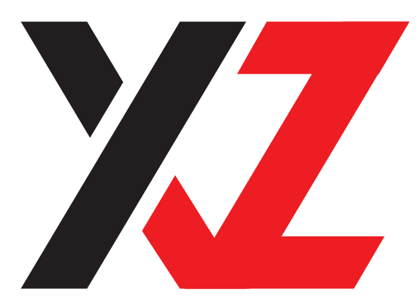

MODERN INNOVATIVE DIGITAL TECHNOLOGY COMPANY LIMITED
新質數字科技有限公司
(Incorporated in Bermuda with limited liability)
(Stock Code: 2322)

- CHANGE OF DIRECTORS;
AND
- CHANGES OF COMPOSITION OF BOARD COMMITTEES

The board (the “Board”) of directors (the “Directors”) of Modern Innovative Digital Technology Company Limited (the “Company”) announces that Mr. Lau Hoi Kit (“Mr. Lau”), in order to devote more time to his other business engagements, has resigned an executive Director, both with effect from 18 August 2026.

Mr. Lau has confirmed that he has no disagreements with the Board and there are no matters in respect of his resignation that need to be brought to the attention of The Stock Exchange of Hong Kong Limited and the shareholders of the Company. The Board would like to take this opportunity to express its sincere gratitude to Mr. Lau for his contributions to the Company during his term of services.

Following the resignation of Mr. Lau, the Board is pleased to announce that Mr. Lee Ka Kiu Derek (“Mr. Lee”) has been appointed as an independent non-executive Director, and members of the Nomination Committee, the Audit Committee and the Remuneration Committee with effect from 18 August 2026.

Mr. Lee, aged 28, graduated from the University of Hong Kong with a Bachelor of Business Administration (Law) degree and a Bachelor of Laws degree, majoring in both accounting and law has an academic background and experience in accounting and law and has obtained a Postgraduate Certificate in Laws. He has been involved in the management and administration of various local and community organizations and has years of experience in organizing and managing large-scale public events.

Mr. Lee will hold office until the next annual general meeting of the Company, and will then be eligible for re-election at such meeting. The term of Mr. Lee’s service as an independent non-executive Director is subject to retirement by rotation and re-election at the annual general meeting of the Company. Mr. Lee will be appointed for a term of three years, which will continue thereafter until terminated by either party giving not less than one month’s prior notice. The Director’s fee of Mr. Lee as an independent non-executive Director under his appointment is HK$15,000 per month, subject to review by the Board from time to time with reference to prevailing market rates for the nature of services rendered.

Save as disclosed above, Mr. Lee has not held any directorship in any other publicly listed companies, whether in Hong Kong or overseas, during the last three years. Mr. Lee does not have any relationship with any other Directors, senior management or substantial or controlling shareholders of the Company. As at the date of this announcement, Mr. Lee does not have any interest in shares of the Company within the meaning of Part XV of the Securities and Futures Ordinance.

Mr. Lee confirmed that he has satisfied all factors set out in Rule 3.13 of the Rules Governing the Listing of Securities on the Stock Exchange (the “Listing Rules”) in assessing his independence.

Save as disclosed herein, there are no other matters concerning the appointment of Mr. Lee that need to be brought to the attention of the shareholders of the Company nor any information to be disclosed pursuant to the requirements of Rule 13.51(2) of the Rules Governing the Listing of Securities on the Stock Exchange.

The Board would like to extend a warm welcome to Mr. Lee in joining the Company.

By order of the Board
Modern Innovative Digital
Technology Company Limited
Mr. Ma Weihua
Chairman

Hong Kong, 18 August 2026

As at the date of this announcement, the Board comprises Mr. Ma Weihua as the
Chairman and the non-executive Director; Ms. Zheng Juhua, Ms. Cao Li and Mr. Lui Chun Pong as the executive Directors; and Mr. Chi Chi Hung, Kenneth, Mr. Chen Chao, Mr. Law Hok Yu and Mr. Lee Ka Kiu Derek as the independent non-executive Directors.

